Prehistoric tomb surveying (8)
Small necropolises in the French Ardèche

Dirk Kruithof, January 2019

The current paper makes part of a broader study through which the existence of a prehistoric geometry was tracked down. Different stages of tomb setups, found at consecutive times and in various areas in Europe form the stepping stones towards the chronicled geometry in ancient mathematical texts. The current paper focuses on one of these areas, the small causes of the southern Ardèche in France. It confirms that the setup and orientation of the studied dolmens can be understood within a grid-of-squares geometry (see PTS-1 ). Grid lines and diagonals through adjacent squares determine the layout of the ground plan of the tombs.

Introduction

The study of the orientations of the Ardèchoise dolmens started in 2005 and can be divided into two phases: an experimental and a systematic one. In the experimental phase the azimuth of back and side slabs were measured in order to compare them with the same measurements elsewhere - Ireland, Brittany, Rhodopi, Mecklenburg and Drenthe. The orientations were obtained using a handheld sounding compass (Recta DP10, ±0.3º) and a water leveller. Because of the slanting sides a levelled stick on a tripod was used to setup a horizontal sightline along a slab's surface. Still the working method was prone to a few degrees fault, but the main question to solve didn't require exactness: Is there a reason to believe that frequently utilized azimuth values exist independent from the latitude? After some time a few clusters of values could be appointed indeed. Meanwhile the study of German dolmens (PTS-7) had advanced some similarities in the setup of ground plans. Encouraged by these findings, the second phase was started. After an investment in photogrammetry necessities , three small necropolises of caussenard type dolmens were selected. In 2012 3D models were produced of the group of La Devèse, in 2014 that of Les Géandes and in 2015 that of Les Granges.

The measuring method

Before taking the photographs, the cardinal points were measured off in a horizontal plane and marked by special targets. Afterwards, all photos were processed in Photomodeler Scanner (a photogrammary application) and a point cloud was produced. Although it is possible to create a triangulated surface from a point cloud, this was not enforced. In a cross-section of such a surface even the smallest irregularities of a stone become visible. Such a high degree of detail is overdone (often we even can't be sure about the exact original placement of a stone) and it disturbs the general picture . Instead the point cloud was reduced to a small horizontal slice which formed the basis for the ground plan. The produced ground plans reflect the dimensions at ground level.

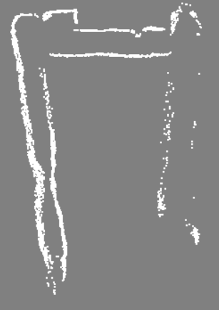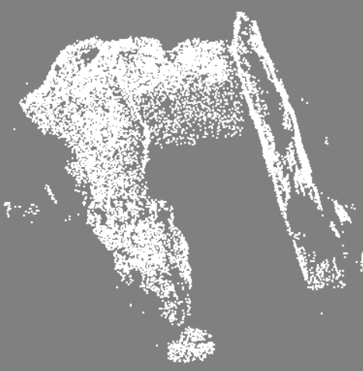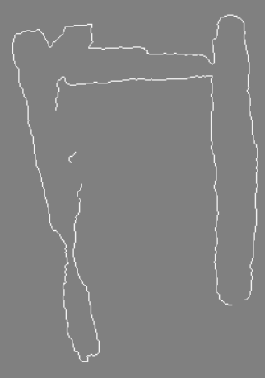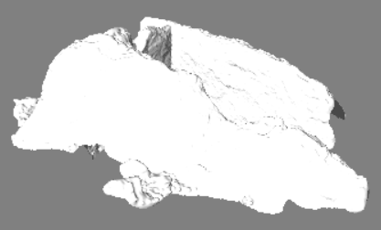

Figure 1
Photogrammetry software creates a 3D model from several carefully taken photographs. From left to right:
a point cloud, a slice of the point cloud in top view, a triangulated surface, and a cross section through the surface in top view. (The dolmen in question is La Devèse A.)

Overview of the processed dolmens

La Devèse
This group is found near Orgnac-l'Aven - an area with beautiful caves. The group consists of five dolmens numbered A to E. Compared to some other dolmens around they form a close group. In this respect the entwined orientation of La Devèse A and B is compared to that of D21 and D22 (Drenthe, the Netherlands) in PTS-4. The orientations of dolmens C and E stand on their own. La Devèse D has been damaged so awfully that its orientation got lost. The other dolmens of the group all have a guard stone which shows the orientation of the grid. La Devèse B seems to have an orientated slab outside the chamber firmly fastened in the mound. A sightline along the stone runs diagonally at 167º in the orientation grid (dotted red line in figure 2). The actual placement as well as the geometrical pattern that evolves from it stand on their own. Therefore it's unsure if the current position of the stone has a special intention.

Les Géandes
The numbering of the tombs differs per author. The current numbering is the latest one by Gély and Pape . From 2002 to 2008 all dolmens of the group have been excavated. In general the excavation plans are comparable to the cross-section through the 3D models of this study, except the plan of Les Géandes 2. Its excavation plan is less trapezoidal then the cross-section of the 3D model. How this can be is a mystery. When describing the slabs of the chamber the authors conclude that "le plan en trapèze de la chambre, plus étroit vers l'entrée, correspond donc bien à l'état initial" . Yet the chamber doesn't constrict so much in their excavation plan. A photograph from 1896 shows the dolmen in almost the same condition as nowadays, except that the entrance slab has been removed or destructed. Also in the excavation plan of dolmen number 5 there is a mismatch with the 3D model. In the model the guard stones stand perpendicular to the chamber axis according to a faulty restoration in 1979 . Apparently the new excavation plan reflects the situation based on the traces in the mound. The original positions of the stones are copied into the ground plan of figure 2. Les Géandes 1 and 3 are heavily damaged.
Les Granges
Of the six visited dolmens four (numbered 1, 3, 5 and 6) were in such a state that a 3D model could be produced. Dolmen 2 lies hidden in the mound and the eastern side slab of dolmen 4 is damaged. Additionally the sightline along the back slab of dolmen 4 runs east-west, so there is insufficient information to get the dolmen orientated. Dolmen 6 is missing its back slab but the setup seems to mirror the situation of Les Géandes 5.

La Devèse C (36¾º) La Devèse A (90º-43º) La Devèse B (90º-43º)

Les Géandes 6 (36¾º) Les Granges 5 (90º-26½º) Les Géandes 2 (9¼º) Les Granges 1 (9¼º)

Les Granges 3 (26½º+13¼º) La Devèse E (90º-6¾º) Les Géandes 5 (90º - 26½º / 18½º)

Figure 2
The ground plans and related geometrical setups of some
necropolises in the Ardèche. In the titles you find the local Les Granges 6 (26½º / 90º-18½º)
denomination followed by the azimuth of the grid in parenthesis. Other azimuth values can be deduced from the geometrical principles involved. In the ground plans a grey dotted line indicates that from there the form of a the stone couldn't be measured anymore. Guard stones are coloured blue. Their alignment along the grid lines seems to be one of their features.
The ongoing development of tomb setups

The most eye-catching difference between the Cause type dolmens of the French Ardèche and the dolmens along the German Baltic Coast (PTS-7) we find in how the inscribed triangle is positioned within the tomb plan. The German dolmens tend to have the slant side of the triangle running along one of the dolmen walls, but in the Cause type dolmens it forms the diagonal of the tomb. Dolmen La Devèse C is the only exception, which could be linked to the fact that this is the only dolmen facing west.

Compared to the setups of the dolmens along the Baltic Coast, the Cause type dolmens show a lot more diversity. There is bigger share of diagonals through three adjacent squares and the share of bisected angles is less. Maybe the diversity shows a more experimental approach and reflects a deeper geometrical understanding. After all the Cause type dolmens were built almost a millennium later. It would not take long before setups applying diagonals through five adjacent squares got invented in the early Bronze Age. Such setups result in just another right triangle, having sides 5×12×13. Here the correct understanding of the setup by diagonals through three adjacent squares forms a prerequisite (see PTS-2).

Reverences to the other papers of this study are abbreviated 'PTS-n', where PTS stands for the study title 'Prehistoric tomb surveying' and 'n' for the serial number of the paper.
Camera: Nikon 300s. Software: Photomodeler Scanner. Laser leveller: Leica Line L2P5 (±0.3 mm/mtr).
Gély and Pape 2014, p.62
Gély and Pape 2014, p.90
Gély and Pape 2014, p.84, fig.94
Gély and Pape 2014, p.107

